Payment Processing Data Engineering Pipeline
An End-to-End AWS Data Lake for Fraud, Dispute, and Compliance Analytics
INSS 661 — Data Engineering | Morgan State University | December 2025
Group 1: Rofiah Akanni, Ayomide Ajibola, Ingrid Djoman | Instructor: Dr. Liqian Bao

Overview
This project designed and built a complete cloud data engineering pipeline for a payment-processing scenario, taking raw, multi-source financial data all the way through to governed, analytics-ready datasets and interactive dashboards. The pipeline runs on Amazon Web Services using a Medallion (Landing → Clean → Curated) data-lake architecture, and it supports three real needs in digital payments: fraud detection, dispute and refund resolution, and regulatory compliance reporting.
It covers the full data-engineering lifecycle — ingestion, storage, transformation, cataloging, dimensional modeling, serverless SQL querying, and visualization — showing how well-built data infrastructure turns fragmented raw data into decision-ready intelligence for downstream users such as machine-learning engineers, data and compliance analysts, and customer-support teams.
Data Modeling
The source data was first modeled as a normalized relational schema (OLTP, 3NF), then restructured into a star schema (OLAP) optimized for analytics and BI querying.
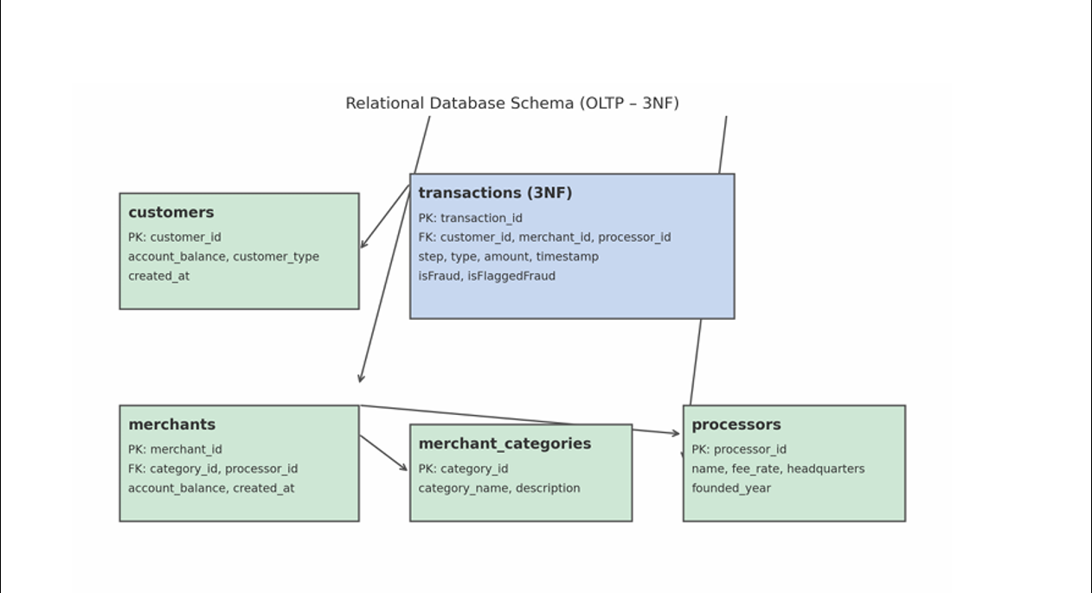
Figure 1 — Source relational schema (OLTP, third normal form).
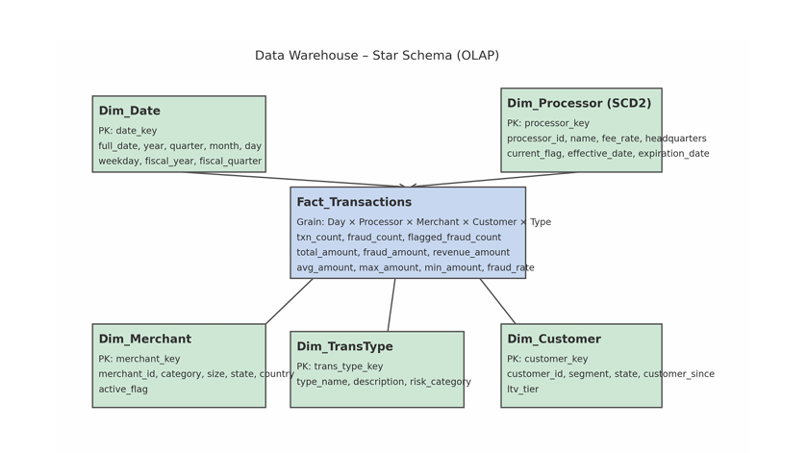
Figure 2 — Analytics data model (star schema, OLAP).
System Architecture
The pipeline uses a three-zone Medallion architecture across Amazon S3, with AWS Glue for transformation and cataloging, AWS Lambda for automation, Amazon Athena for querying, and Tableau for visualization.
Data Lake Zones (Amazon S3)
- Landing Zone (Raw): source files stored in native XLS/CSV format, full lineage preserved, no schema enforcement.
- Clean Zone (Refined): validated, standardized data converted to Parquet (Snappy compression), cataloged as a Glue database.
- Curated Zone (Analytics-ready): modeled, joined datasets optimized for downstream querying and BI.
Data Storage & Cataloging
Raw files were ingested into S3 and converted to Parquet through AWS Glue. Lambda triggers automatically updated the Glue Data Catalog as new data arrived. The Clean Zone database held six governed tables: transaction_data, crm_support_data, financial_data, fed_payments, mastercard_benchmarks, and visa_fraud_benchmarks.
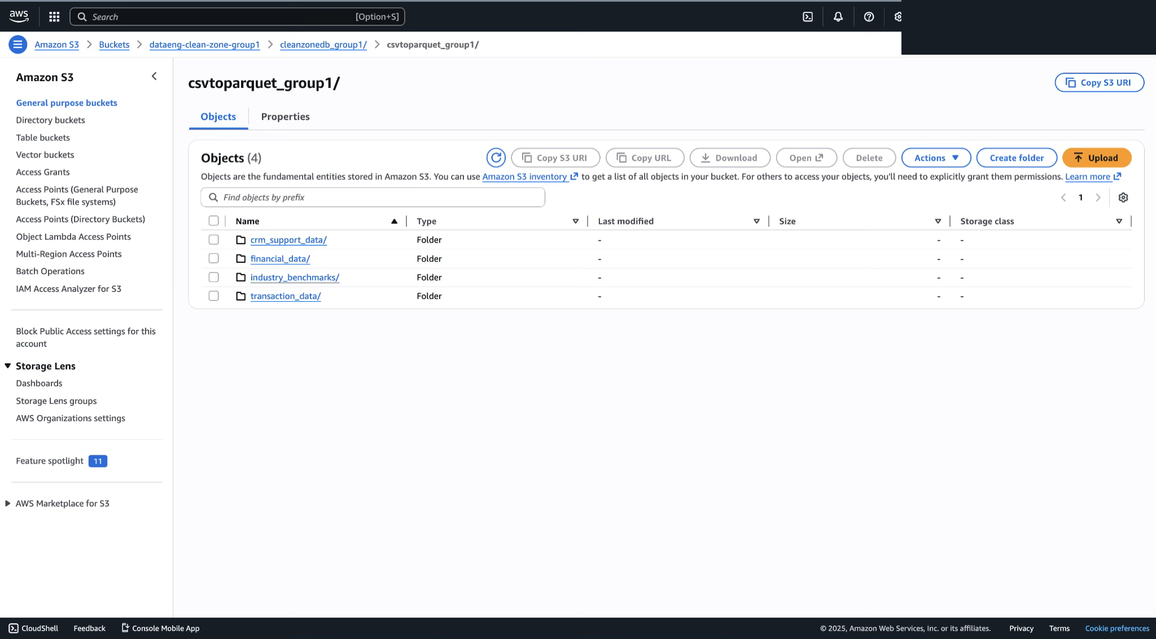
Figure 3 — Clean Zone database and tables in the AWS Glue Data Catalog.
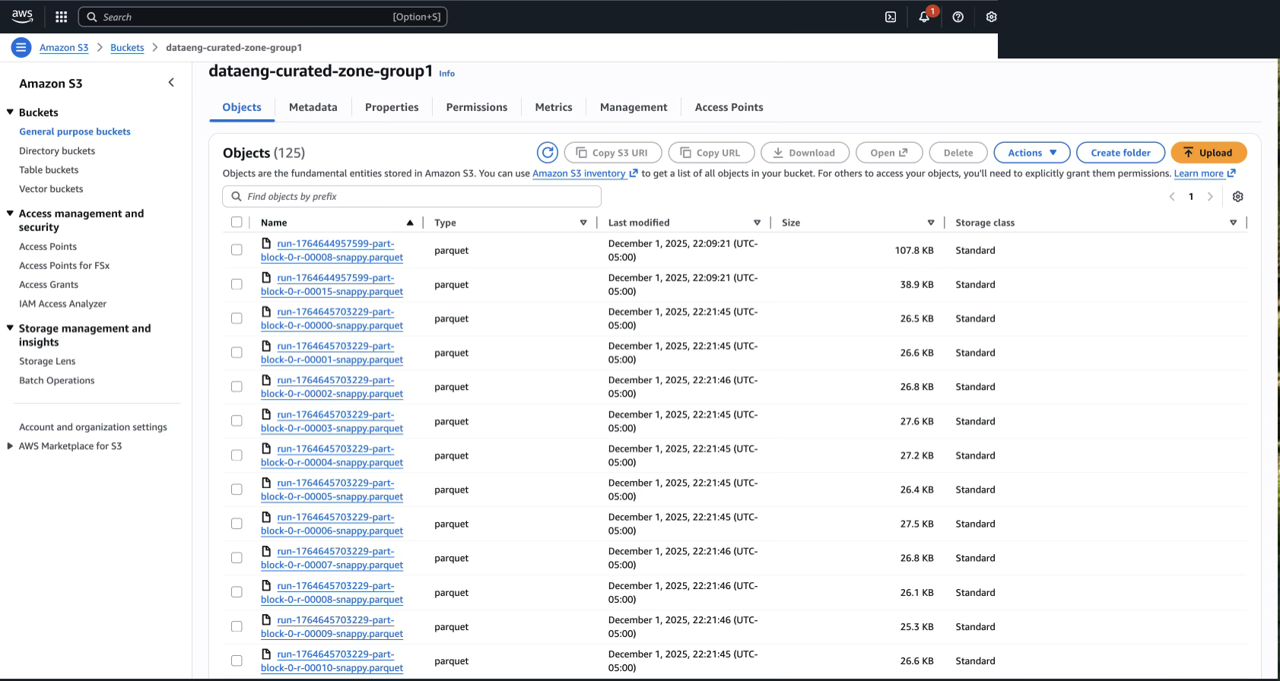
Figure 4 — Cataloged tables and schemas in AWS Glue.
Transformation & Data Modeling
Transformations were carried out in AWS Glue Studio using both visual transforms and SQL — type enforcement, deduplication, null handling, schema standardization, value/code standardization ("Yes"/"No" → 1/0; billions/trillions → millions), period splitting, and multi-table joins into a consolidated final_joined_dataset.
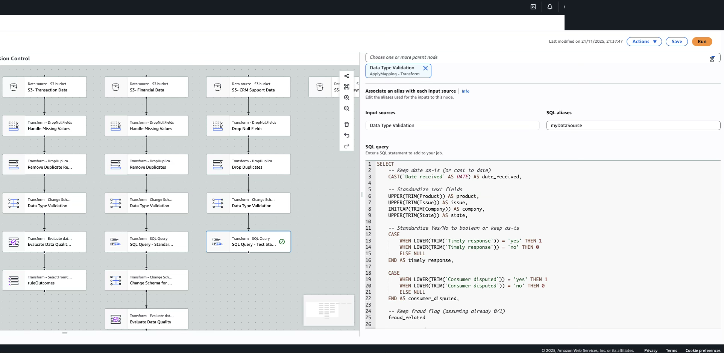
Figure 5 — AWS Glue Studio visual ETL job.
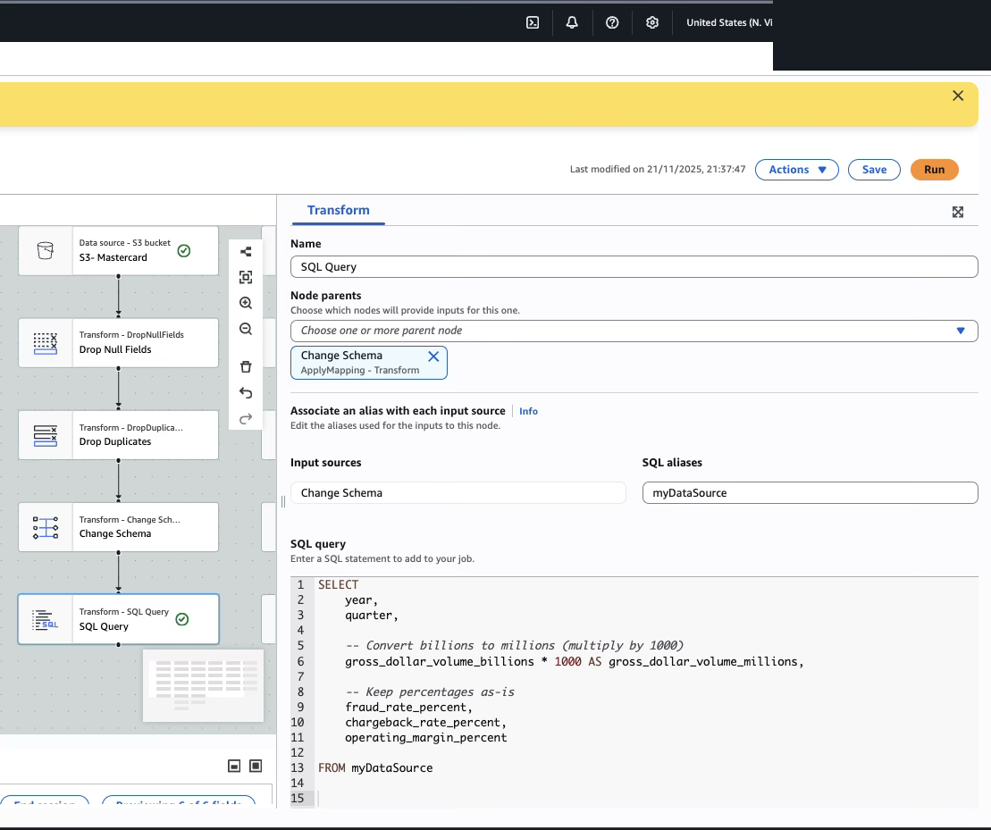
Figure 6 — SQL transformation in Glue Studio (value/text standardization).
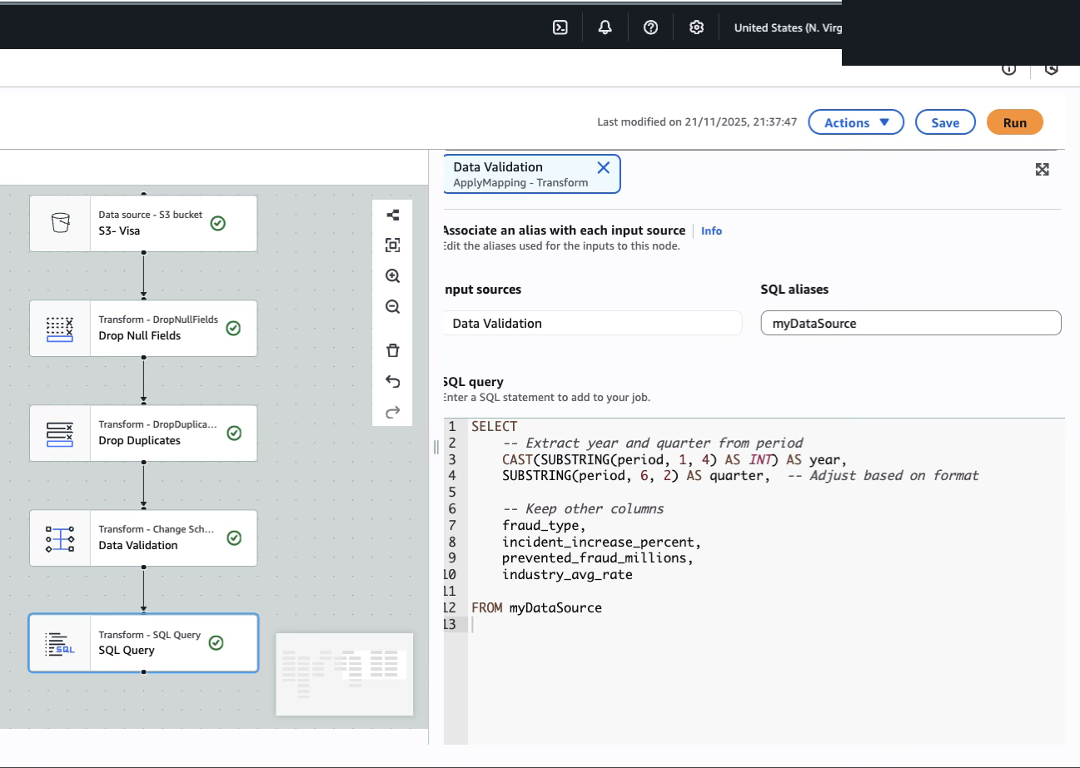
Figure 7 — Glue Studio join workflow producing the final joined dataset.
Querying (Amazon Athena)
Analytical querying was performed in Amazon Athena using serverless SQL directly on the curated Parquet tables, integrated with the Glue Data Catalog.
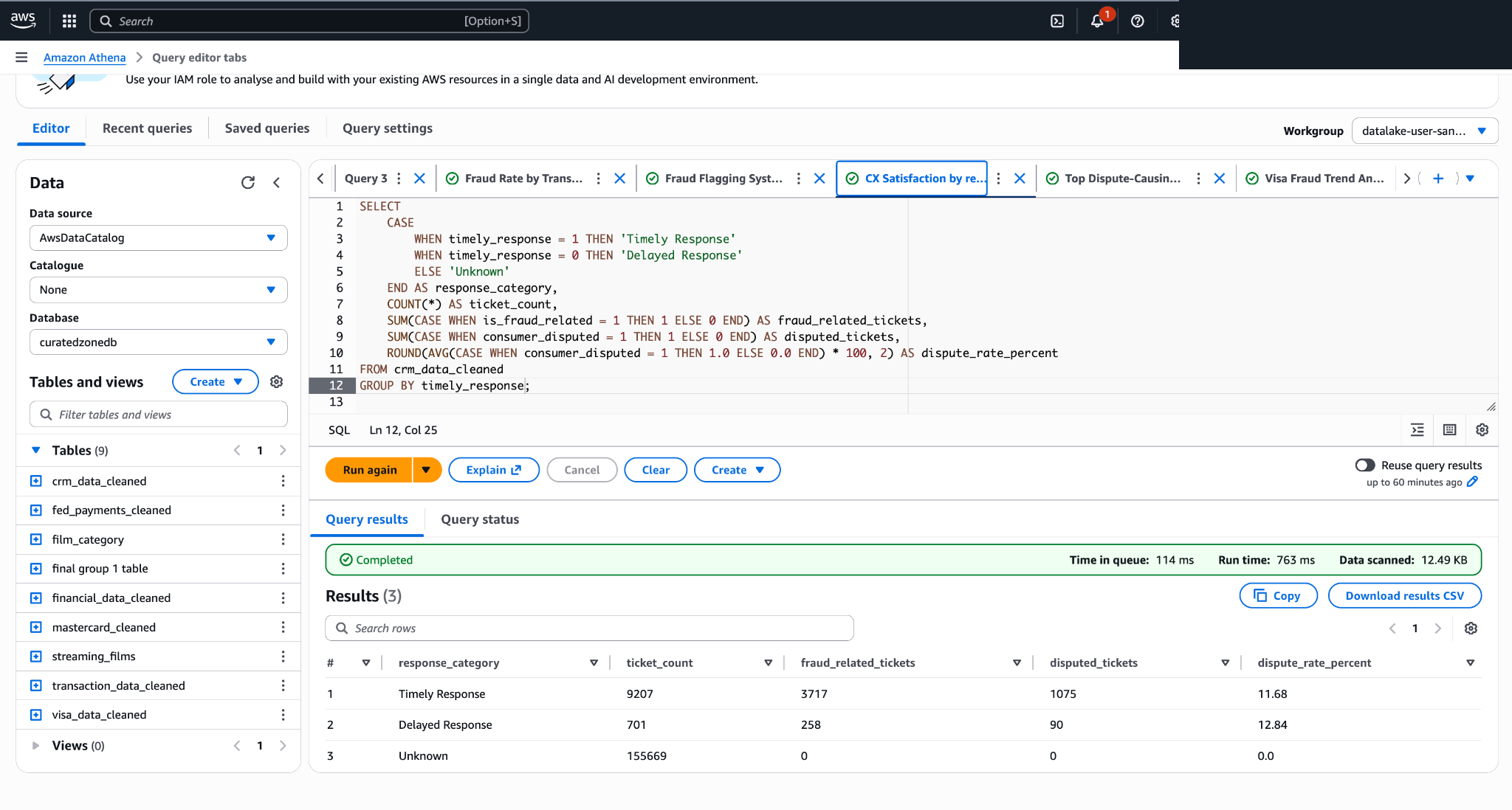
Figure 8 — Amazon Athena SQL query and results over the curated tables.
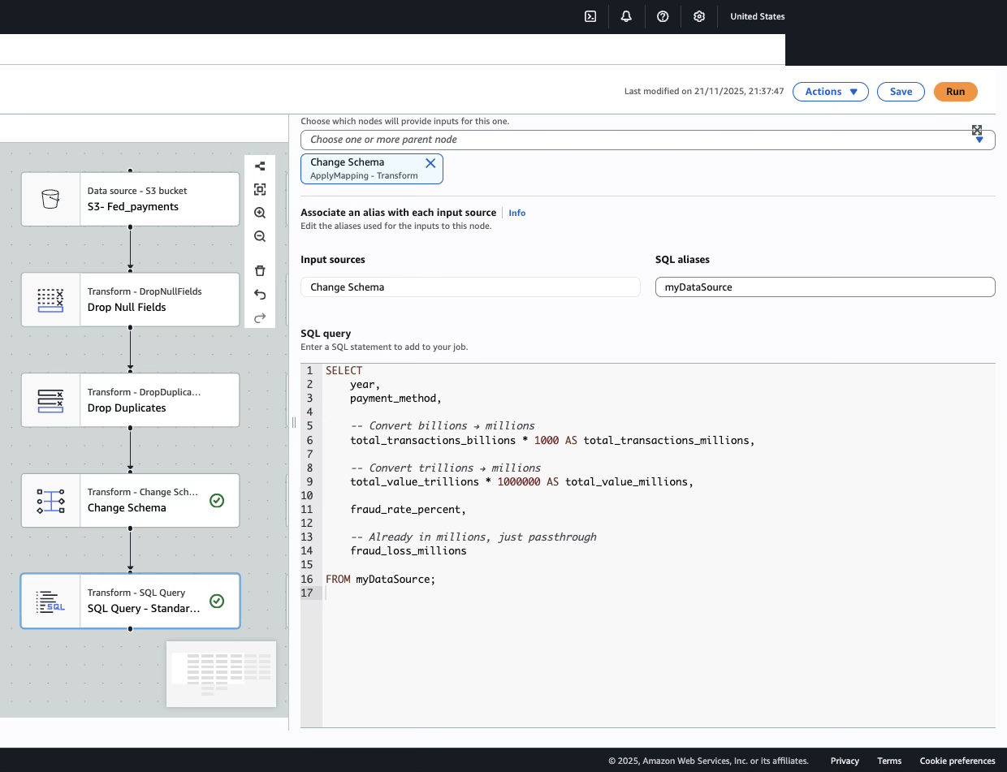
Figure 9 — Athena query for a payment-processing business question.
Analysis & Key Findings
Problem 1 — Fraud Detection
- DEBIT transactions had the highest fraud rate at 0.75%; TRANSFER carried the greatest exposure at $15,295.91 in losses (0.59%); PAYMENT was safest at 0.22%.
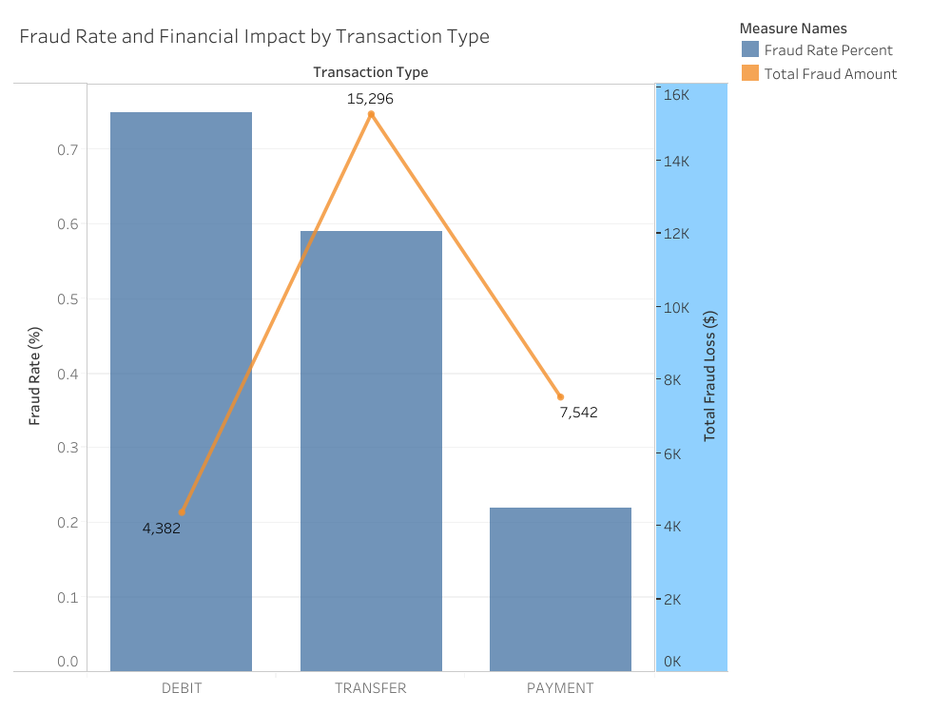
Figure 10 — Tableau: fraud rate and financial impact by transaction type.
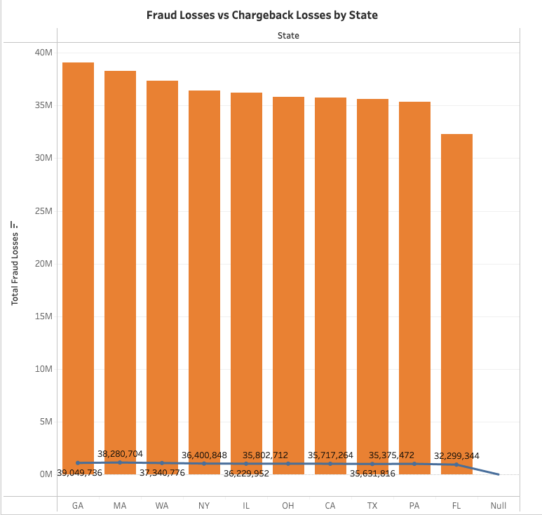
Figure 11 — Tableau: fraud vs. chargeback losses by state.
Problem 2 — Dispute & Refund Resolution
- Billing disputes were highest-risk for Money Transfer products at 13.64%; Credit Card products showed elevated duplicate-charge (12.70%) and billing (12.64%) disputes.
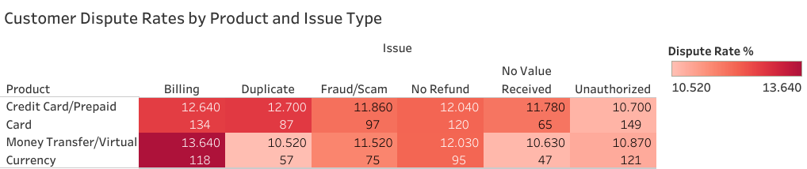
Figure 12 — Tableau: customer dispute rates by product and issue type (heat map).
Problem 3 — Compliance & Regulatory Reporting
- Visa PERC trends showed a worsening 2024 landscape: Enumeration +25%, Account Takeover +20%, Card-Not-Present +14%, with $760M prevented in Q4.
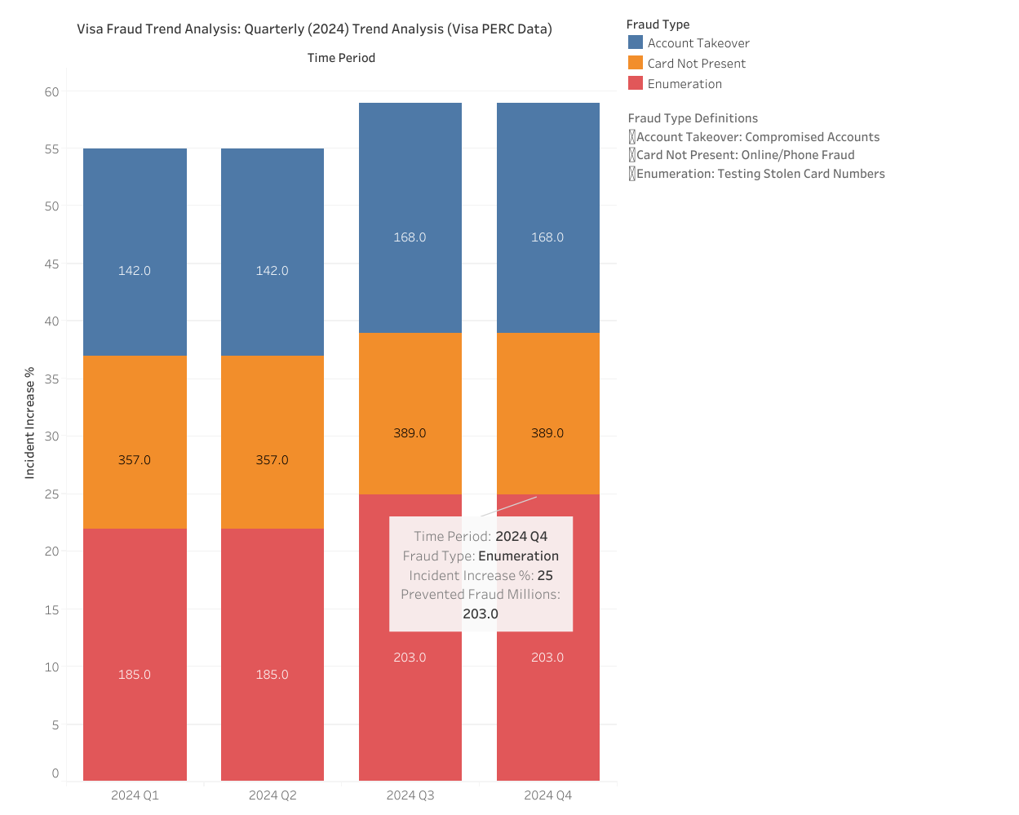
Figure 13 — Tableau: quarterly fraud-trend analysis (Visa PERC data).
Consolidated Dashboard
All three problem areas were brought together into a single interactive Tableau dashboard for a unified view across fraud, disputes, and compliance.
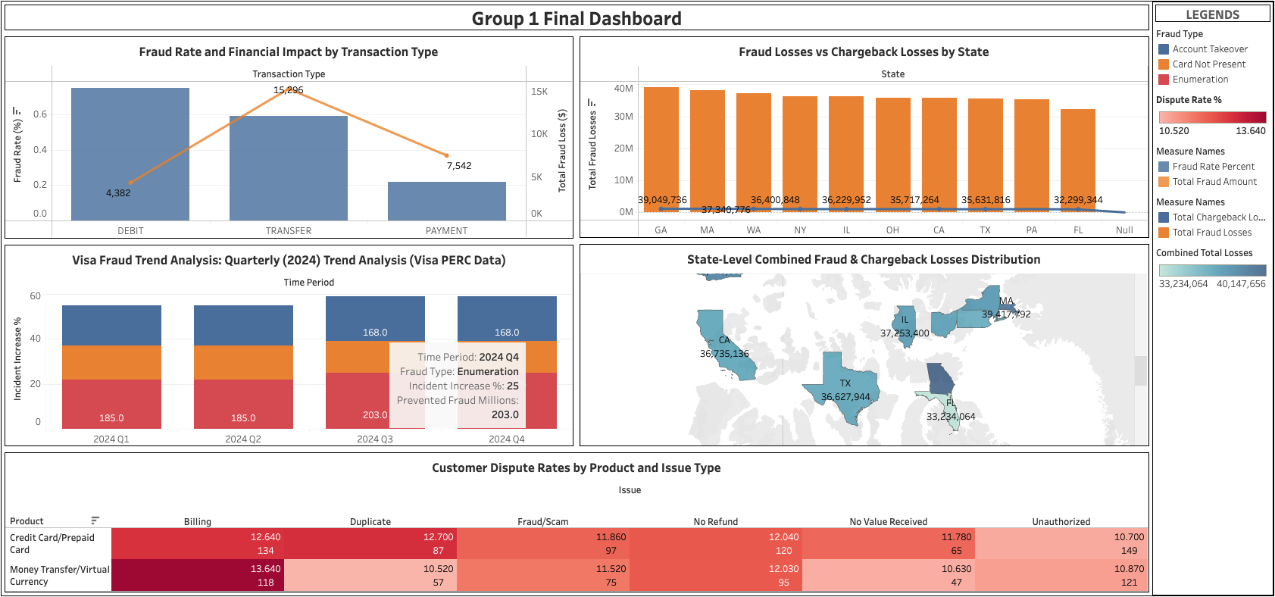
Figure 14 — Final consolidated Tableau dashboard.
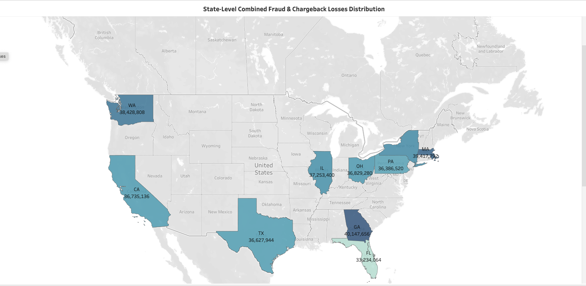
Figure 15 — Geographic view: fraud exposure by U.S. state.
Technologies & Skills Demonstrated
Area | Tools / Concepts
Cloud data engineering | AWS S3, AWS Glue (Studio + Data Catalog), AWS Lambda, Amazon Athena
Architecture | Medallion data lake (Landing/Clean/Curated); serverless, event-driven automation
Data modeling | OLTP 3NF and OLAP star schema; denormalization and multi-table joins
ETL & quality | XLS→Parquet, schema enforcement, deduplication, null handling, standardization
Querying | SQL on Amazon Athena over curated Parquet tables
Governance | Data lineage, cataloging, and auditable pipelines (AML / PCI-DSS context)
Visualization | Tableau visuals and interactive dashboard design
Team & Contributions
This was a collaborative Group 1 project; all three members contributed across the pipeline. Ayomide Ajibola contributed to the data pipeline and analysis and focused on the visualization work — developing the Tableau visuals and dashboard that translated the curated query outputs into decision-ready insights across the fraud, dispute, and compliance problem areas.

